$b词条$**定义**：每 $31b词条2$ 倍的伤害期望提升。因此 $1b词条$ 为 $\sqrt[31]{2}$ 倍伤害期望提升，而且 $b词条$**数和伤害期望D**成**对数和指数**的关系，便于计算与记忆。本文中仅有主词条和套装效果的圣遗物伤害期望为 $D_{default}$， $b词条$ 为 $0$.

$$b=31*\left(\log{D}-\log{D_{default}}\right)$$

$$D=2^{\frac{b}{31}}*D_{default}$$

定义依据：我希望定义一个 $b词条$，它可以准确地描述圣遗物词条的提升，而不受到稀释的影响。显然， $b词条$ 应该被定义成对数形式：

$$b=k*\left(\log{D}-\log{D_{default}}\right)$$

$$D=2^{\frac{b}{k}}*D_{default}$$

自然，我们希望比例常数 $k$ 是一个整数，并且有一定的意义，这会给计算和记忆带来方便。于是我便从大家都喜欢的双暴进行取值。

已知双暴从 $50\%$/ $100\%$ 到 $100\%$/ $200\%$ 几乎没有稀释（**双暴几乎不稀释**公理），每 $1$ 暴击增量在 $\left[\frac{2}{3},\frac{1}{\sqrt{2}}\right]$（约 $\left[0.666,0.707\right]$）之间，这确实是一个很小的范围（暴率与暴伤配平时，收益 $f$ 与权重暴率 $CR$ 的关系为： $f=1+\frac{CR^{2}}{2}$， $相对导数=\frac{导数}{原函数}=\frac{\frac{df}{dCR}}{f}=\frac{CR}{1+\frac{{CR}^{2}}{2}}$）。因此，一条暴击 $3.3\%$ 的收益在区间 $\left[2.2\%,2.33\%\right]$ 内。又知 $1b词条$ 的收益为 $\frac{D}{D_{default}}=2^{\frac{1}{k}}=\sqrt[k]{2}$，在根指数 $k$ 为整数的前提下，只有 $\sqrt[31]{2}$ 在这个范围内.代入得下式：

$$b=31*\left(\log{D}-\log{D_{default}}\right)$$

$$D=2^{\frac{b}{31}}*D_{default}$$

算法根据公认的概率表生成圣遗物，并模拟多名玩家（以图中 $PERSONS$ 数量为准）进行刷取。算法对 $4+1$ 套装的处理方式为将所有圣遗物的 $\frac{6}{10}$ 认为是正确的套装，该处理对于几乎只刷一个本的情况模拟得较好，而对刷本种类多的模拟程度略差（想必各位旅行者是比较专一的吧）。算法为简单的循环一对一比较；其中每月清空圣遗物背包，所导致的词条数偏低完全可以忽略，根本比不上模拟人数少导致的误差（实际上很多旅行者确实是这么做的）.

本文仅发布于bilibili，未经允许禁止转载。

$default_dmg$ 为只有主词条时的伤害期望（通常为{攻击/精通}、属伤、{暴率/暴伤}，视情况调整），本文提到的伤害均为 $90$ 级 $10/10/10$ 打 $90$ 级 $10\%$ 抗性的伤害期望.

大括号内为刷 $12$ 个月时不同玩家不同圣遗物主词条的选取比例（有没有一种可能，我是说有可能，这个选取在第一个月就已经确定了）.

表中数据为中位数，图是每个月画一条不同玩家的 $b词条$ 分布，线上的点 $(x,y)$ 表示有 $y$ 名玩家 $b词条$ 数小于 $x$.

WEAPONS = [

    Staff_of_Homa, # 护摩之杖

    Dragons_Bane # 匣里灭辰

]

ARTIFACT_SETS = [

    Crimson_Witch_of_Flames, # 炽烈的炎之魔女

    Wanderers_Troupe2, # 流浪大地的乐团2+炽烈的炎之魔女2

    Shimenawas_Reminiscence # 追忆之注连

]

class charactor:

    def HP(self) -> float:

        return self.BaseHP*(1+self.exHPs)+self.exHP

    def ATK(self) -> float:

        if self.Homa:

            return self.BaseATK*(1+self.exATKs)+self.exATK+self.HP()*(0.0626+0.018)

        else:

            return self.BaseATK*(1+self.exATKs)+self.exATK+self.HP()*0.0626

    def RATE(self) -> float:

        return self.ATK()*2.4257

    def BONUS(self) -> float:

        return 1+self.Bonus

    def CRIT(self) -> float:

        return 1+self.CRIT_Rate*self.CRIT_DMG

    def reaction(self) -> float:

        return self.reactionRatio*self.BaseReactionBonus*(self.exReactionBonus+2.78*self.elementalMastery/(1400+self.elementalMastery))+1-self.reactionRatio

    def resistance(self) -> float:

        return 0.9

    def defend(self) -> float:

        return 0.5

    def damage(self) -> float:

        return self.RATE()*self.BONUS()*self.CRIT()*self.reaction()*self.resistance()*self.defend()  # 直伤

首发：bilibili

作者：不死の祥云

<https://www.bilibili.com/read/cv16108500>

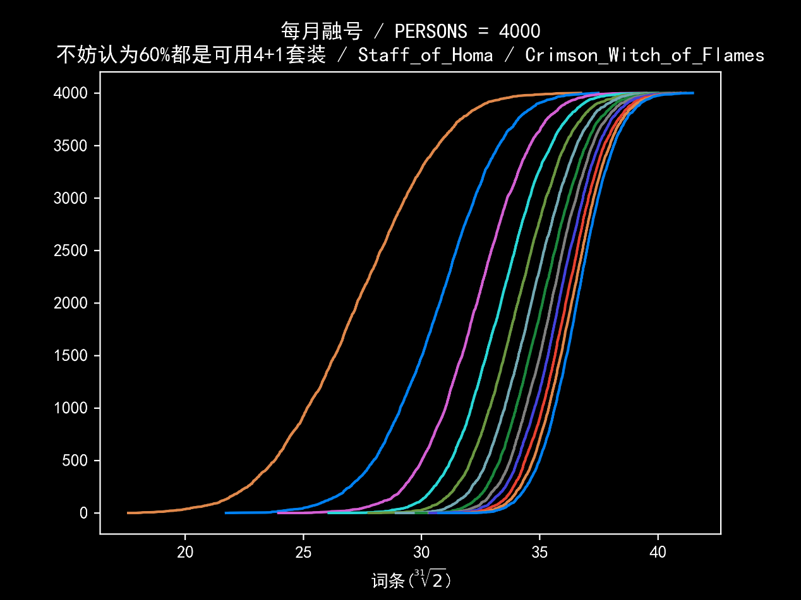每月融号

PERSONS = 4000

不妨认为60%都是可用4+1套装

Staff_of_Homa

Crimson_Witch_of_Flames

default_dmg = 22204.48481322316

{'Sands of Eon, HP%': 0.44325, 'Sands of Eon, Elemental Mastery': 0.55675}

4000 / month

1 month 40857.1815512548 27.27189622048242

2 month 44177.276673173066 30.76605501246094

3 month 45771.12084838535 32.35118220860967

4 month 46809.821105372605 33.35476474527351

5 month 47564.53547299399 34.07009089382304

6 month 48176.59593006787 34.64192217857454

7 month 48688.57285027536 35.11469556021697

8 month 49103.52258627779 35.49423820140433

9 month 49442.32563384244 35.80176071500098

10 month 49768.739546401375 36.09605128368024

11 month 50045.06807750052 36.34368081936555

12 month 50293.74654137402 36.5653658292716

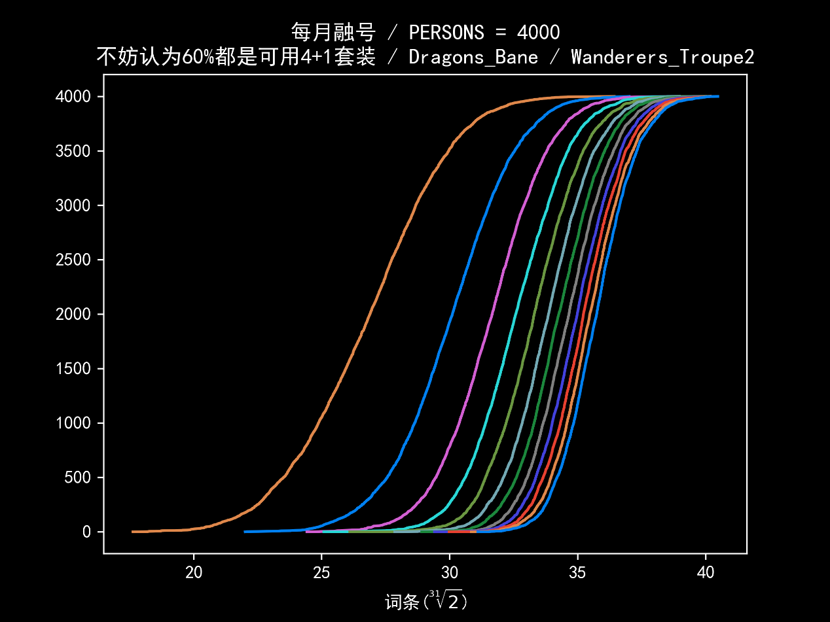每月融号

PERSONS = 4000

不妨认为60%都是可用4+1套装

Staff_of_Homa

Wanderers_Troupe2

default_dmg = 20913.14526847643

{'Sands of Eon, Elemental Mastery': 0.44825, 'Sands of Eon, HP%': 0.55175}

4000 / month

1 month 38481.81711518615 27.272772972136465

2 month 41464.56950848138 30.611540837735518

3 month 42941.61554110224 32.176958838979374

4 month 43926.84776597008 33.191480491275556

5 month 44637.23349228604 33.9089643705794

6 month 45196.37605382051 34.46570836165875

7 month 45660.944393192796 34.92306996092043

8 month 46046.60450431368 35.29922633425765

9 month 46392.22468327746 35.633662246734644

10 month 46676.60702382355 35.906978804287455

11 month 46957.98645653788 36.1757752712984

12 month 47178.71169700627 36.38550503214188

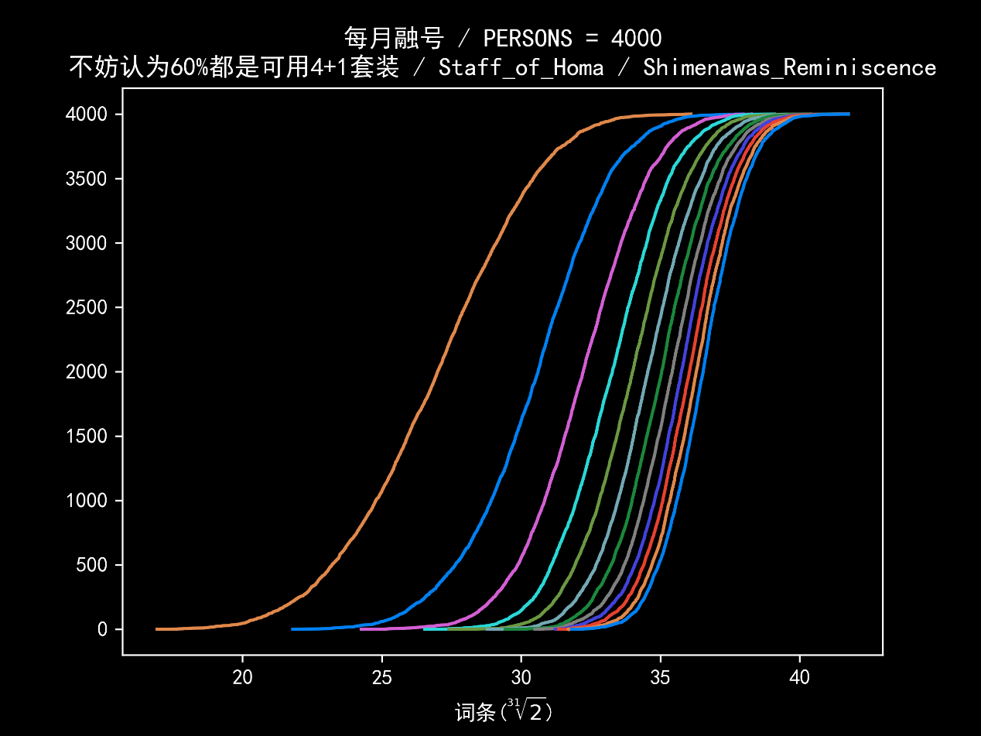每月融号

PERSONS = 4000

不妨认为60%都是可用4+1套装

Staff_of_Homa

Shimenawas_Reminiscence

default_dmg = 23663.840719682736

{'Sands of Eon, HP%': 0.246, 'Sands of Eon, Elemental Mastery': 0.754}

4000 / month

1 month 43273.77944984117 26.995075331123054

2 month 46912.20006686661 30.605646346676576

3 month 48643.14024002032 32.22611573669924

4 month 49797.257305866944 33.27484317791388

5 month 50608.10703091534 33.99721222304272

6 month 51233.36758443041 34.54638378138985

7 month 51806.501568531894 35.04391641253869

8 month 52248.35749692511 35.423744572662

9 month 52628.74597328834 35.74816993643368

10 month 52973.28583161901 36.0400033170431

11 month 53264.25715538154 36.284988312638546

12 month 53559.95539187661 36.532585879201136

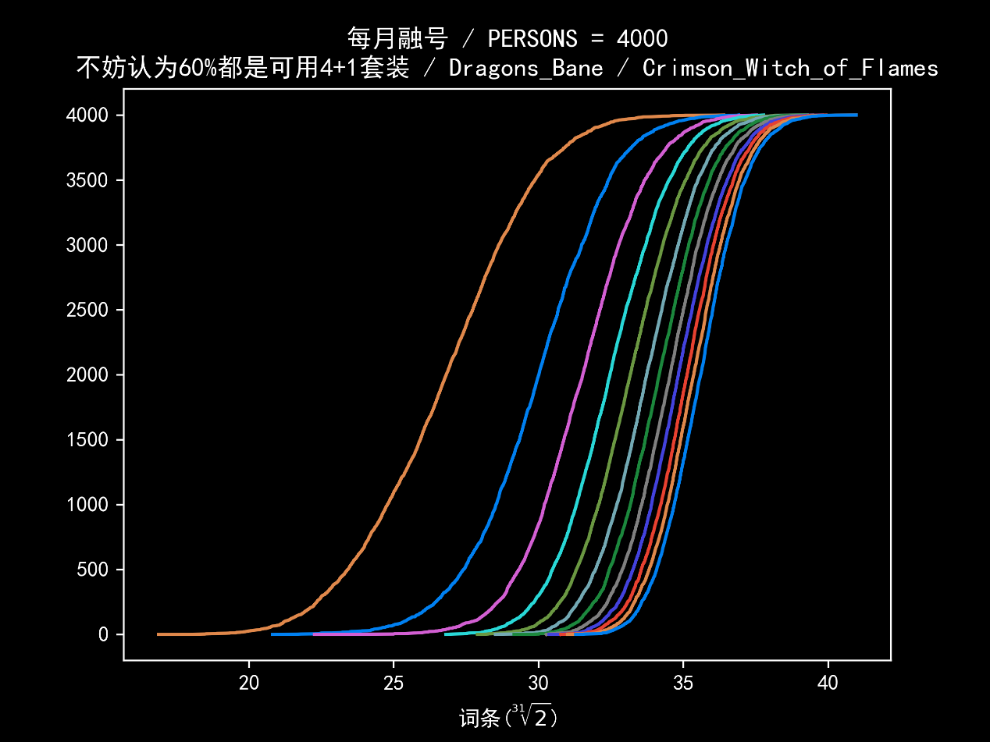每月融号

PERSONS = 4000

不妨认为60%都是可用4+1套装

Dragons_Bane

Crimson_Witch_of_Flames

default_dmg = 19597.18839816453

{'Sands of Eon, HP%': 0.97025, 'Sands of Eon, Elemental Mastery': 0.02975}

4000 / month

1 month 35690.820273416255 26.812097552066717

2 month 38336.298723343476 30.00999543260926

3 month 39659.951244811804 31.528122751488798

4 month 40501.59547125543 32.46729369524168

5 month 41139.346926352235 33.16603837065147

6 month 41664.40466746804 33.73322907063984

7 month 42068.23328096706 34.16462089473706

8 month 42426.56155518694 34.543953308183

9 month 42701.23953118233 34.83256914565053

10 month 42983.332352631325 35.12705009259231

11 month 43206.05765985341 35.358194268313255

12 month 43440.36981716588 35.60008066705831

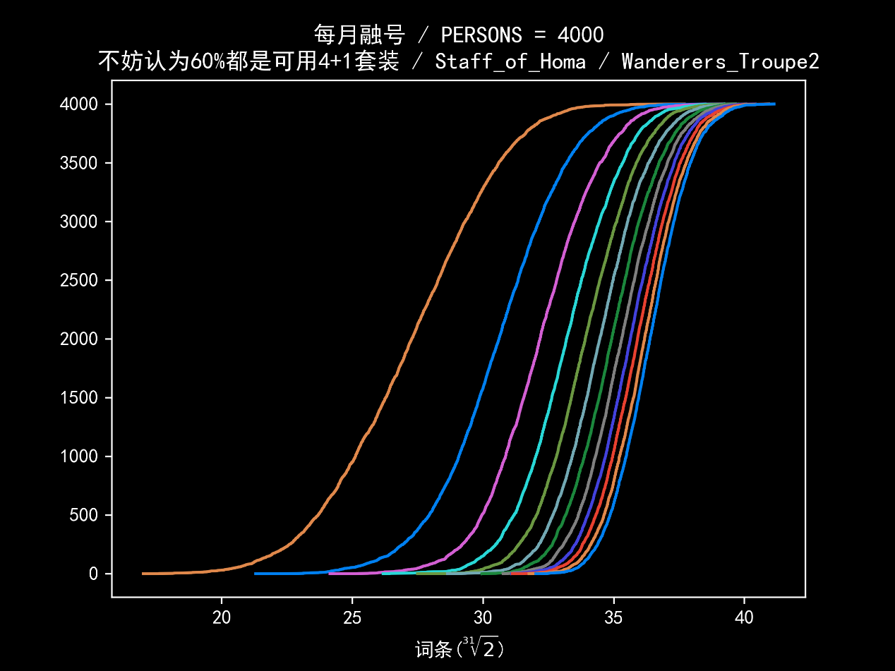每月融号

PERSONS = 4000

不妨认为60%都是可用4+1套装

Dragons_Bane

Wanderers_Troupe2

default_dmg = 18352.228441800795

{'Sands of Eon, HP%': 0.98075, 'Sands of Eon, Elemental Mastery': 0.01925}

4000 / month

1 month 33478.49284606895 26.885659123475484

2 month 35974.98441574254 30.102203025624085

3 month 37251.90062921654 31.662122194875042

4 month 38023.13177890877 32.57858540628011

5 month 38642.99532141293 33.30180179864106

6 month 39125.603116063925 33.85688983013915

7 month 39478.95143241739 34.2589809382916

8 month 39833.124587952276 34.65841531432652

9 month 40120.998862007655 34.98047035024074

10 month 40337.37749721015 35.22102313469494

11 month 40563.515797495 35.47105085787084

12 month 40808.420088893625 35.74025967931357

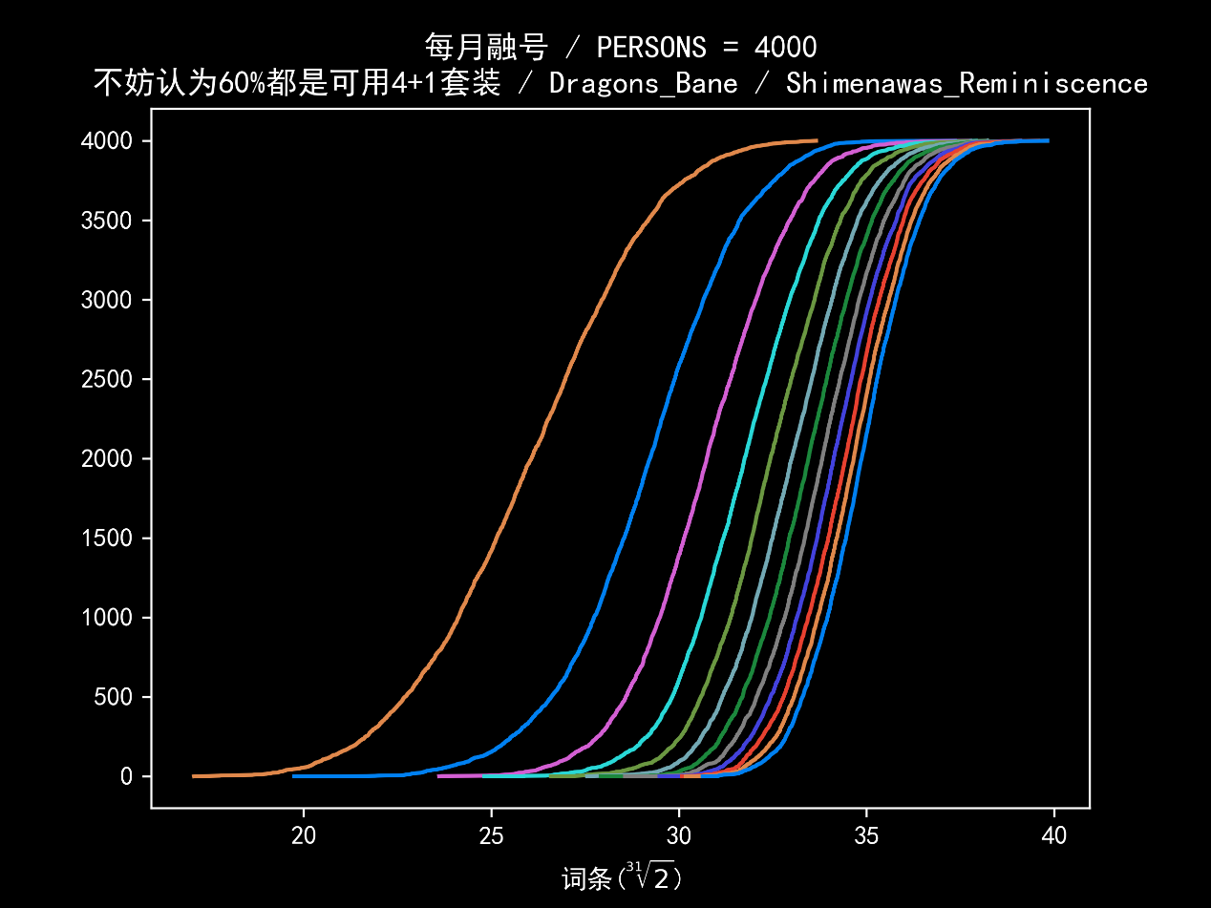每月融号

PERSONS = 4000

不妨认为60%都是可用4+1套装

Dragons_Bane

Shimenawas_Reminiscence

default_dmg = 20956.358320934283

{'Sands of Eon, HP%': 0.90325, 'Sands of Eon, Elemental Mastery': 0.09675}

4000 / month

1 month 37534.98294903907 26.066281566506973

2 month 40278.30408056222 29.22106204690644

3 month 41666.04130184772 30.736004020943042

4 month 42616.306316924616 31.744543140931846

5 month 43277.83521407539 32.4334493388059

6 month 43828.732663936564 32.999156763358215

7 month 44269.38610296131 33.44656129589121

8 month 44637.28427516048 33.816697862041636

9 month 44941.474229516025 34.12044187496876

10 month 45256.810754655206 34.43315347766908

11 month 45481.039839036974 34.654193323282996

12 month 45695.630586384716 34.86471377535829